Log on to AWS console

Create Total 4 Subnets.

2 Public and 2 Private

Public 1 Subnet (10.0.1.0/24) (AZ 1)

Public 2 Subnet (10.0.2.0/24) (AZ 2)

Private 1 Subnet (10.0.3.0/24) (Az 1)

Private 2 Subnet (10.0.4.0/24) (AZ 2)

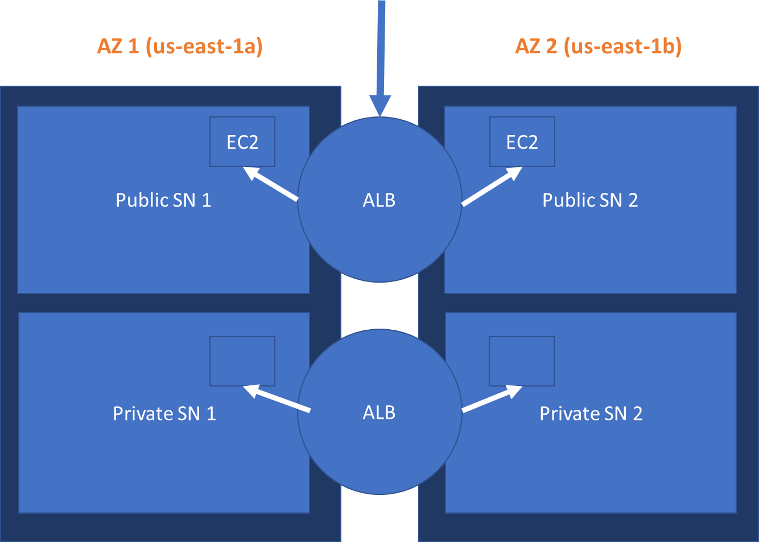

Go to EC2

Scroll left side pane and click on Load Balancers

Create 2 Instance in 2 in Public Subnet 1 and another one Public Subnet 2

User below command to install http server using user script

*sudo su*

*sudo yum update -y*

*sudo yum install -y httpd*

*sudo service httpd start*

*sudo chkconfig httpd on*

*cd /var/www/html*

# Below line will get change for Servers

**For webserver 1**

*echo "<h2>This is the </h2> <h1 style='color:Red;'> WebServer 1 </h1>"> index.html*

**For webserver 2**

*echo "<h2>This is the </h2> <h1 style='color:Blue;'> WebServer 2 </h1>"> index.html*

**For blog server 1**

*mkdir blog*

*cd blog*

*echo "<h2>This is the </h2> <h1 style='color:Green;'> BlogServer 1 </h1>"> index.html*

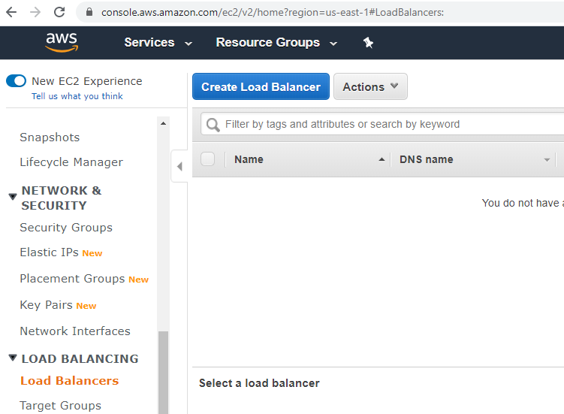

Click on Create Load Balancer

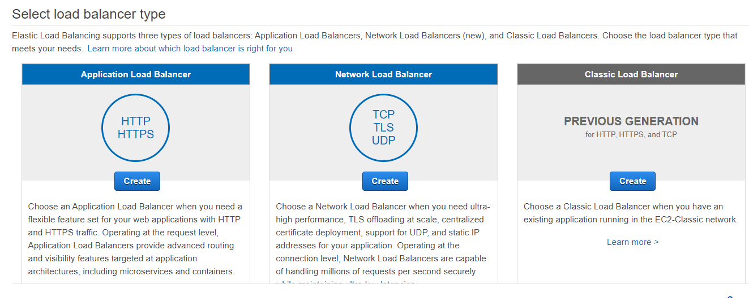

Select Application Load Balancer >> Click Create

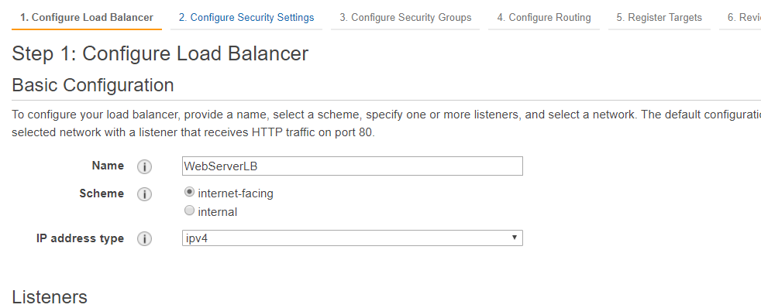

Provide name of the Load Balancer

Scheme should be >> Internet-facing

IP Address type – Ipv4

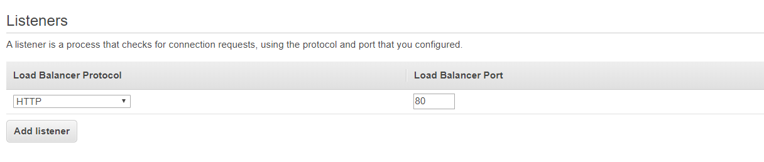

Listerner just keep Port 80

Availability Zone.

Select both the subnets available

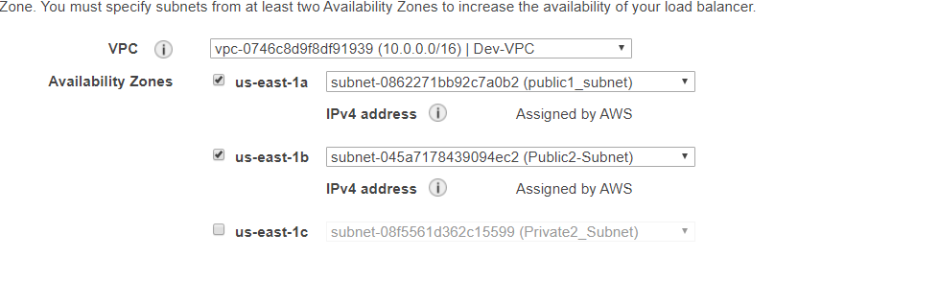

Create NEW Security Group and Assign just 80 port

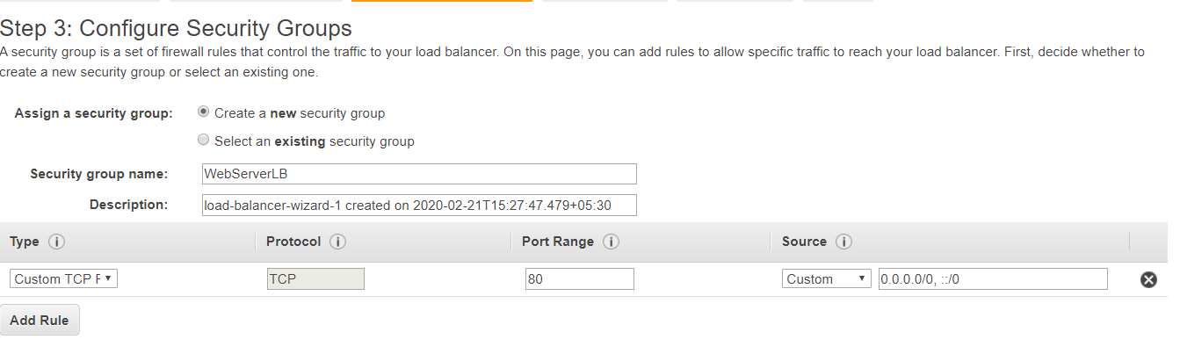

Create Target Group

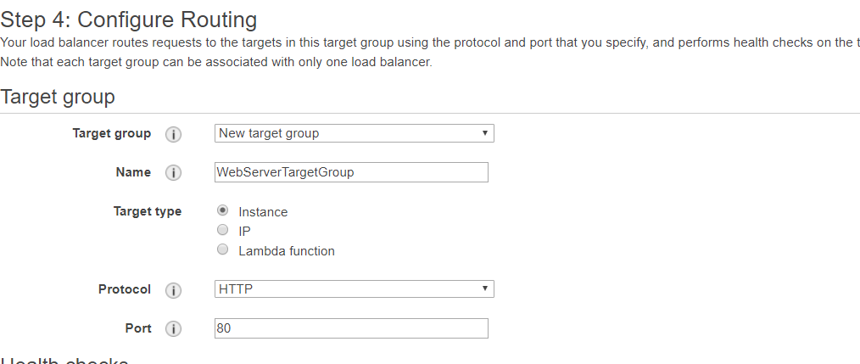

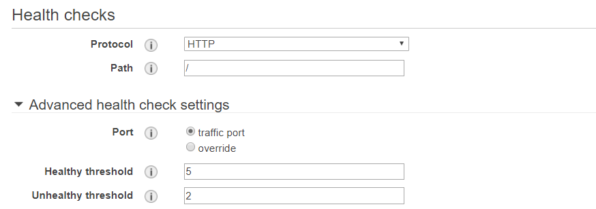

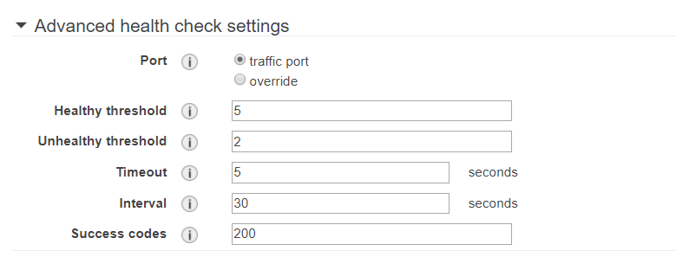

Select Instances to be used from the List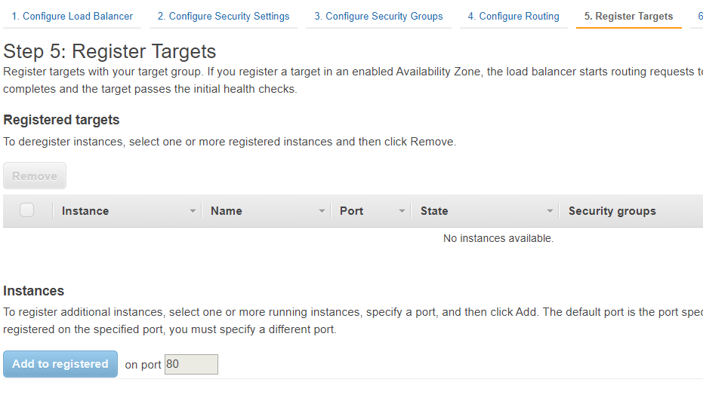

Create on Review and Create …